Chapter 10, Solution 2.

Using Fig. 10.51, design a problem to help other students better understand nodal analysis.

Although there are many ways to work this problem, this is an example based on the same kind of problem asked in the third edition.

Problem

Solve for V_{o} in Fig. 10.51, using nodal analysis.

2 Ω
+
_
+

j4 Ω V_{o}
4∠0º V –j5 Ω

–

Figure 10.51 For Prob. 10.2.

Solution

Consider the circuit shown below.
2
V_{o}
+
_

–j5 j4
4∠0º V-

At the main node,
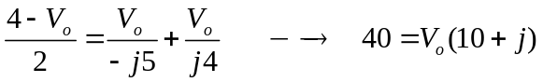

V_{o} = 40/(10–j) = (40/10.05)∠5.71˚ = 3.98∠5.71˚ V

